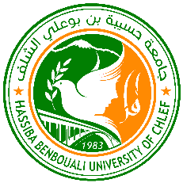
Hassiba Benbouali University of Chlef
FACULTY OF TECHNOLOGY
Organize
The Fourth Doctoral Symposium on Technology:
Process, Mechanical and Electrical Engineering

DST’04-2024

Septembre 29-30, 2024

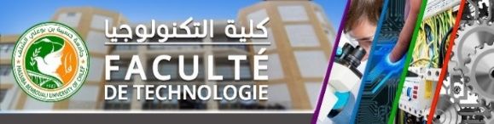
Supported by
Faculty of Technology, Hassiba Benbouali University of Chlef.

Presentation of the Faculty of Technology
The Faculty of Technology is a study and research unit at Hassiba Benbouali University of Chlef. The license’s and master’s programs are taught in four departments: Mechanical Engineering, Electronics, Electrical Engineering and Process Engineering. The fifth department of the faculty is the Department of the Common Core in Technology (T.C.T.), established in 2019 by the Minister of Higher Education and Research, which supports specialties in the Science and Technology domain across several faculties.
Research at the Faculty of Technology is conducted in various fields, including Materials, Renewable Energy, Sustainable Development, Chemical Engineering, Energy, Environment, and Artificial Intelligence, etc. This research is concretized through doctoral studies in both the new LMD system and the classical system, supported by the efforts of seven research laboratories.
Objectives of DST'04-2024
Following the success of the first, second and third National Doctoral Symposiums on Technology, the faculty is pleased to announce the fourth edition, DST'04-2024, to be held at Hassiba Benbouali University in Chlef, Algeria, on Sptembre 29-30, 2024. This scientific event will provide an excellent opportunity for both research scholars and postgraduate students to interact and share their experience and knowledge of technology and its applications.
The symposium aims to offer a platform for researchers and practitioners from both academia and industry to share cutting-edge developments in several fields: electrical engineering, mechanical engineering, process engineering, and automation. Additionally, it will focus on drafting concrete project ideas, helping PhD students discuss their work, address questions related to their research, and receive constructive feedback.
Honorary chair
Pr. GHOUINI Larbi | University rector
Organizing Committees
Organizing Committee Chair:
Pr. FARES Chahinez | Dean of the Faculty of Technology
Organizing Committee Members:
Dr. ALLOUACHE Hadj | Vice-dean of pedagogy
Pr. BELMADANI Bachir | President of the Scientific Council of the Faculty
Dr. KHATI Azedine | Head of the mechanical engineering department
Dr. MOSTEFAOUI Mohamed | Head of the Electrical Engineering department
Dr. MAHMOUDI Larbi | Head of the Process Engineering department
Dr. OUMSALEM Abdallah | Head of the Electronics department
Dr. BENAOUDA Mahmuod | Head of the Common Core in Technology department
Pr. HAMOU Zahloul | Laboratory of Rheology and Mechanics
Pr. BELALIA Azedine | Laboratory of Mechanics and Energetics
Pr. KHELIL Ali | Laboratory of Control, Testing, Measurement and Mechanical Simulation
Dr TAHRAOUI D. Naima | Laboratory of Water and Environment
Pr. LAIDANI Yaklef | Laboratory of vegetal Chemistry, Water-Energy
Pr. TALEB Rachid | Laboratory of Electrical Engineering and Renewable Energies
Dr. TAHRAOUI Souaad | Laboratory of Signals, Systems and Artificial Intelligence
Dr. MAIZIA Abdelhakim | MCB, UHBC
BELABED Heni | Secretary General of the Faculty
HABBAL Brahim | Head of Cooperation and External Relations at the Faculty
BELKACEMI Mohamed | Head of Faculty Resources
Scientific Committees
Scientific Committee Chairmen:
Pr. ZIDANE Ibrahim
Scientific Committee Members:
HAMOU Zahloul, Pr-UHBC
HOCINE Abdelkader, Pr-UHBC | BOUYAKOUB Ismail, MCA-UHBC
MERIEM BENZIANE M., Pr-UHBC | LATROCHE Maamar, MCA-UHBC
KHELIL Ali, Pr-UHBC | AISSA BOKHTACHE Aicha, MCA-UHBC
HADJ MELIANI Mohammed, Pr-UHBC | SAHRAOUI Hamza, MCA-UHBC
ZERROUT Amar, MCA-UHBC | BENBOUALI Abderrahmane, MCA-UHBC
HADJ MILOUD M, MCA-UHBC | DELLALI M. MCA-UHBC
MENDAS Mohamed, Pr-UHBC | BENICHOU Boucif, MCA-UHBC
BERIACHE Mhamed, Pr-UHBC | BENZOUAOUI Ahmed, MCA-UHBC
BRAIKIA Mohamed, MCA-UHBC | OUAGEUAD Malika, MCA-UHBC
LABBACI Abdellah, Pr-UHBC | ZITOUNI Ahmed, MCA-UHBC
DOUANI Mustapha, Pr-UHBC | KHOUIDMI El Houari, MCA-UHBC
DJAFER Lahcen, Pr-UHBC | MAIZIA Abdelhakim, MCB-UHBC
HENINI Ghania, Pr-UHBC | FEKAOUNI Faouzi, MCA-UHBC
BENSEBIA Bensaber, Pr-UHBC | BENHAMOU A. MCB-UHBC
TAHRAOUI D. Naima, MCA-UHBC | KARAS Abdelkader, Pr-Univ Tiaret
DJAFER A. Pr-UHBC | MEDDAHI Youssouf, MCA-UHBC
BELMADANI Bachir, Pr-UHBC | EL MILOUDI khaled, Pr-UHBC
DJAHBAR Abdelkader, Pr-UHBC | KERFAH Rabah, Pr-Univ Khemis Miliana
TALEB Rachid, Pr-UHBC | BELHADJ Djilali AEK, MCA-UHBC
BENYOUCEF Djillali, Pr-UHBC | TOUALBIA Asma, MCA-UHBC
YAHDOU Adil, MCA-UHBC | MEHEDI Faycal, MCA -UHBC
KHADRAOUI Aek, Pr-Univ Khemis Miliana | BESSAAD Taib, MCA-UHBC
YOUCEF KAMLA, MCB-UHBC | BOUNADJA Elhadj, MCA-UHBC
TAHRI Taoufik, Pr-UHBC | BELKACEM Nafissa, MCB-UHBC
HELLAIMI Mhamed, Pr-UHBC | AISSAOUI Ahmed, MCA-UHBC
BOUDJEMA Zinelabidine, Pr-UHBC | MESMOUDI Asma, MCA-UHBC
BOUNAADJA Mohamed, MCA-UHBC | ADARDOUR Haroun Errachid, MCA-UHBC
DEBAB Mohamed, MCA-UHBC | KANSAB AEK, Pr-UHBC
OUAGUED Malika, MCA-UHBC | TAHRAOUI Souaad, MCA-UHBC
Aims and Topics
1: Process engineering covers, but is not limited to: electrochemistry; corrosion; process intensification; adsorption; environment; etc.
2: Electrical Engineering: covers, but is not limited to: power electronics; electrical networks; electrical control; renewable energy and energy conversion; PV systems; etc.
3: Mechanical engineering covers, but is not limited to: mechanical behavior of metal alloys; polymers and composites; tribology & surface coating; fluid mechanics; mass and heat transfer; the rheology of complex fluids; technologies and manufacturing processes; and renewable energies in mechanics.
4: Electronics covers, but is not limited to: automatic systems; control; diagnosis; and artificial intelligence.
Key dates

• All PHD students of the Faculty of Technology at UHB Chlef must present their works through oral presentations.
• The official language of the DST'04-2024 meeting is Arabic, English or French.
• Plenary sessions, as well as invited talks and contributions, should be done in English.
• Oral presentation dates: Sptembre 29-30, 2024.
The program of presentations and poster sessions should be announced as soon as possible on the website of the faculty or on the website of the university.
Presentation

1: Direct or remote presentation

Contact

E-mail: doctoral.symposium@univ-chlef.dz
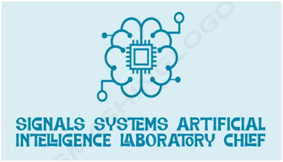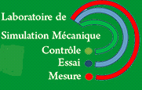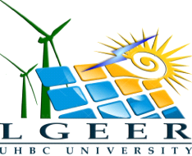Tél: (+213) 6 61 53 32 04
